Kinect Google

Final report

Kinoogle
Bryan Blanchard
Benton Minges
Julio Montero
Cory Walker

Department of Computer Science and Engineering
Texas A&M University

5/10/2011

Section 6 User’s Manuals

6.3 Operation Instructions

6.3.1 Main Menu
Please ensure that Google Earth is running when you start Kinoogle.
When Kinoogle is started the program window will appear across the top of your screen.

At the right of the Kinoogle window are the two status indicators for your hands.
Red - Hand not detected
Yellow - Hand detected and tracked
Green - Hand detected, tracked, and engaged

Engaged - Your hand is clenched into a fist.
Unengaged - Your hand is completely open and unclenched.

To activate hand tracking, wave one hand. When the status indicator for HAND1 turns yellow, wave your other hand in a location near the first hand. When the status indicator for HAND2 also turns yellow, the program will automatically enter Map Mode, and the labels for the boxes will change accordingly.

6.3.2 Map Mode
You are able to manipulate the map depending on the sub mode:

Pan/Zoom - You may scroll the map in any direction, and zoom in and out. When entering Map Mode you are set to this sub mode automatically.
- To scroll the map, engage one hand, and move that hand as if you were dragging the map on another surface such as a table. To zoom in, disengage both hands and bring them together. Then engage both hands and pull them apart.
- To zoom out, disengage both hands and move them apart. Then engage both hands and bring them together.

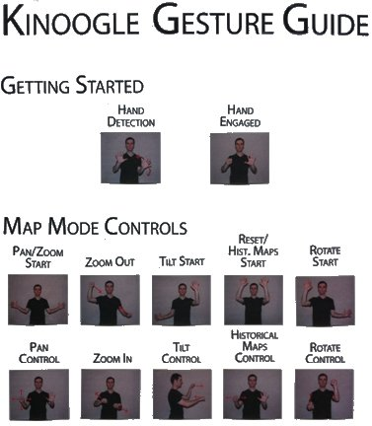

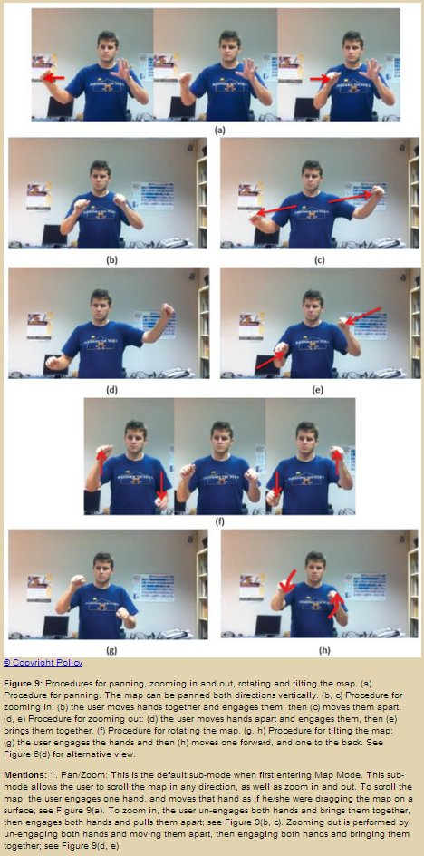

6.3.2.1 Map Mode: Sub Modes

There are three sub-modes:
- Rotate
- Tilt
- Reset

To switch between sub modes, you must make and hold a specific pose for a short time. The arrows to the right of each box indicate how you must hold your hands to trigger each mode. A progress bar will fill as you hold the pose

- Rotate - You may adjust the 360 rotation angle of the map.
- To rotate the map, engage both hands, and move them in opposite y directions, as if you were using a steering wheel.

To enter Rotate Mode, hold your right hand up and move your left hand to your left, as in the picture below.
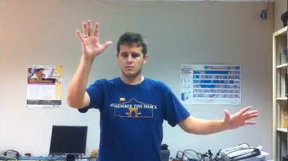

- Tilt - You may tilt the map plane.
- To tile the map, engage both hands and move them in opposite z directions.

To enter Tilt Mode, hold your left hand up and move your right hand to your right, as in the picture below.
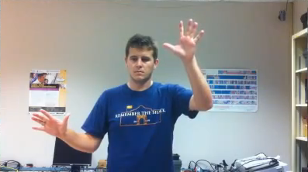

- Reset - The map’s tilt and rotation angles will be reset.
- To reset the map, disengage both hands and bring them up to the same level as your head.

To reset the map, hold both hands up as in the picture below.
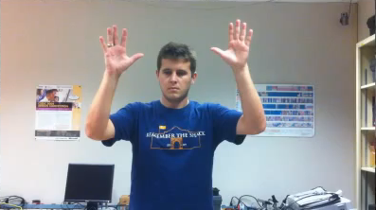

Resetting the map will also set up the historical maps mode.
To change the time period, engage one hand and move the slider to the desired time period.

Sub-modes combined on one page:
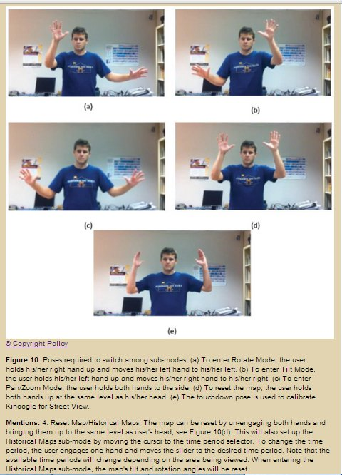

6.3.3 Street View
To enter street view, use the Pan/Zoom mode to zoom in as much as possible into a street that supports street view capabilities. Google Earth will automatically enter its own street view.
To calibrate Kinoogle for street view, make a touchdown pose, as in the picture below.
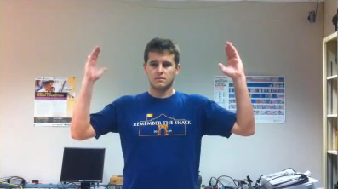
The window will also change its labels accordingly.

The controls for Map Mode, including the poses to change the sub mode, are disabled while in street view.

Twisting your shoulders will rotate the view. Ensure that you only twist your shoulders, and not your entire body.

To move forward, swing your arms while standing in place. You do not have to move your legs.

To exit street view, extend both of your arms straight out horizontally.
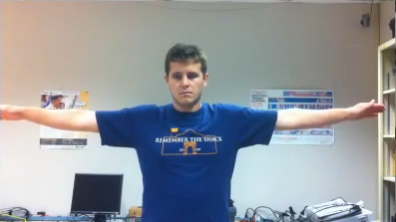
Google Earth will exit street view and zoom out.
Then you must recalibrate the hand detection in order to reenter Map Mode and continue manipulating the map.

