INSERT SCHOOL LOGO
Our Launch of a Classroom Blog
INSERT DATE
Dear Parents,
We have some exciting news; our class is trialling a blogging system for both school and homework! Students will now be given the option to either type their homework (blog), record a video (vlogging) or audio (podcasting), and upload images/pictures to hand in their homework.
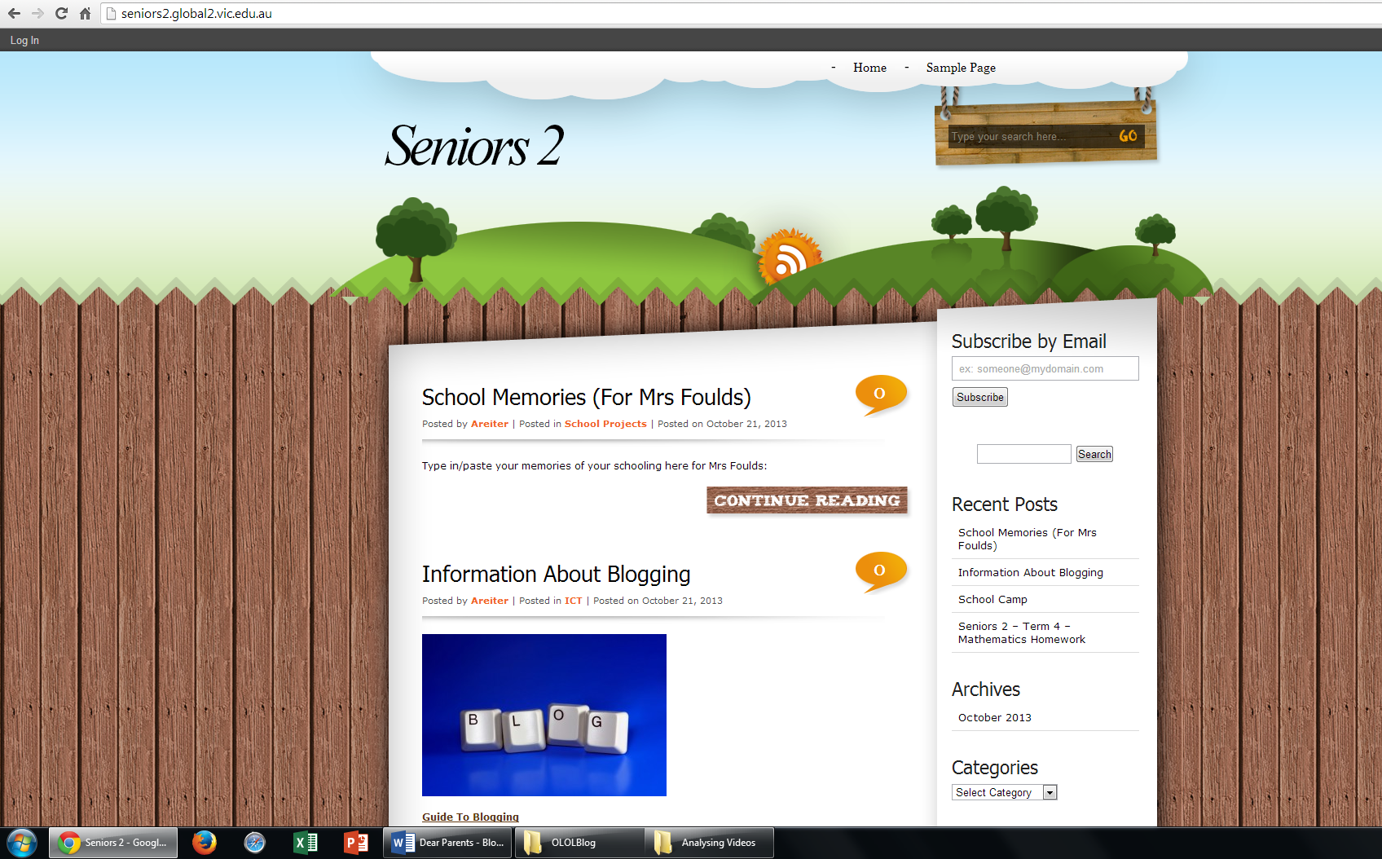 | This week the students will be trained up on how to post text, video, audio and images during class. It is expected that by INSERT DATE, that the students will have posted at least one entry whilst at school and one entry at home. Usernames and passwords are not required to add simple text/comments to the blog. However, for more advanced blogging, the students will be given usernames and passwords as soon as some kinks are figured out. it is anticipated that students should be posting/blogging
each night as part of their homework. Parents and family members can subscribe to our blog too to keep up to date with what is happening at school! Wow!
The blog is part of the services offered by INSERT BLOG PROVIDER. For safety reasons, only people with the password INSERT PASSWORD can access the page. Students are reminded that all behaviours on this website, including blog entries, must adhere to the rules outlined in the ‘Blogging at INSERT SCHOOL NAME Policy’ (see attached).
Additionally, student work and the student interactive eportfolios will also be available on our blog at the end of the year.
The blog can be accessed via MyClasses or by visiting INSERT LINK. I have had no trouble accessing the blog using Internet Explorer or Safari. However I have encountered difficulties when using Chrome or Mozilla Firefox. If you experience problems visiting the blog using Chrome or Mozilla Firefox, please use Internet Explorer or Safari (these can be downloaded via a simple Google Search).
As per the senior years homework policy, please ensure that your child has completed their homework by the Thursday night of each week (P.S. If you subscribe to our blog, your smart phone will beep to notify you when they have uploaded their work! )
Yours sincerely,

INSERT TEACHER NAMES

